GRIDTALK™
GridTalk 4.2 User Guide

Release No: 4.2
About CrimsonLogic eTrade Services
CrimsonLogic eTrade Services is a wholly-owned subsidiary of CrimsonLogic Pte Ltd. Established with the mission to serve the trade and logistics sector, we offer innovative and secure eTrade services to facilitate businesses to complete critical trade documentation and communication quickly and accurately. We enable businesses to connect and collaborate with their global trading partners seamlessly in a secure environment.

We have developed a suite of products under TradePalette®. TradePalette® is an end-to-end electronic trade management solution that enables the exchange and sharing of information for seamless business communications. It facilitates businesses in their business-to-business (B2B) and business-to-government (B2G) trade communication, coordination and collaboration, resulting in significant cost and time savings.

Our other core business is TradeWeb™ which streamlines the cargo declaration process by enabling users to send declarations to the Singapore Customs, IE Singapore, and other controlling agencies directly from the computer. The whole process of launching a cargo declaration to printing of a Cargo Clearance Permit (CCP) can be completed within minutes through the use of Trade Declaration services.

With a call centre in operation 24x7, our dedicated helpdesk serves as the business support centre for customer enquiries and troubleshooting. Our data centre infrastructure provides disaster recovery services to ensure that our customers’ data is protected and can be retrieved quickly to resume operations.

Proprietary Information
This User Guide contains information, which is proprietary to CrimsonLogic eTrade Services Pte Ltd. No part of this User Guide may be reproduced in any material form (including photocopying or storing it in any medium by electronic means and whether or not transiently or incidentally to some other use of this publication) without the written permission of CrimsonLogic eTrade Services Pte Ltd except in accordance with the Copyright Act of Singapore (Cap. 63).

GridTalk™
GridTalk 4.2 User Guide

Contents

Chapter Page

1 About the Guide 4
1.1 Related Documentation 4
2 Getting Started with GridTalk 5
3 Using GridTalk User Interface 6
3.1 Tabs 7
3.2 Links 7
3.3 Navigation Panel 8
3.4 List View Page 9
3.5 Detail View Page 13
3.6 Fields 16
3.6.1 Text Fields 16
3.6.2 Drop Down Select Boxes 16
3.6.3 Checkboxes and Radio Buttons 16
3.6.4 Multi-selector 16
3.6.5 Files 17
3.6.6 Embedded List Views 17
4 Registry 19
4.1 Viewing and updating the Company Profile 20
4.1.1 To view your company profile 20
4.2 Managing business entities 21
4.2.1 To view a list of all business entities 22
4.2.2 To create a own business entity 23
4.2.3 To delete a business entity 25
4.2.4 To create a partner business entity 25
5 Partner 26
5.1 Managing Partners 27
5.1.1 To create a partner 27
5.2 Managing partner types 29
5.2.1 To create a partner type 29
5.3 Managing Partner Groups 30
5.3.1 To create a partner group 30
6 Documents 31
6.1 Understanding Information about a Document 32
6.1.1 General Information 32
6.1.2 Traceability Information 33
6.1.3 Partner Information 34
6.1.4 Communication Information 35
6.1.5 Attachment Information 36
6.2 Managing Documents in the Import folder 37
6.2.1 To view the import folder 37
6.2.2 To import a document 38
6.3 Managing documents in the Outbound Folder 39
6.3.1 To view the outbound folder 39
6.3.2 To manually send a document 40
6.4 Managing documents in the Inbound Folder 41
6.4.1 To view the inbound folder 41
6.5 Managing documents in the Export Folder 42
6.5.1 To view the export folder 42
6.5.2 To manually export a document 43
7 Document Searching 44
7.1 Configuring Search Queries 45
7.1.1 To create a search query for searching by Grid Document 45
7.1.2 To create a search query for searching by user document 47
7.2 Running Search Queries 49
7.2.1 To run a search query and view searched documents 49

About the Guide

This GridTalk 4.2 User guide is especially designed for the end users. The guide contains the step-by-step instructions and visual screens to enable you to perform the simple tasks while you are getting acquainted with the features in GridTalk 4.2.

It covers mainly the following features which you should be able to perform the tasks:

- Registry
Instructions on how to create business entities to identify and engage partners in the business process.

- Partner
Instructions on how to create partner types and groups to describe an active partner when you are engaged in the document transaction with your partner.

- Document
A quick summary on the different movements of documents, such as Import, Export, Outbound and Inbound. Information on how the active documents are exported, imported, transacted, time-stamped, received and sent to trading partners.

- Document Search
A quick summary of how the active and existing documents are searched for based on the search criteria you set up.

Related Documentation

The following documents directly support GridTalk 4.2:
- GridTalk 4.2 Installation Guide
- GridTalk 4.2 Administration Guide

Getting Started with GridTalk

To launch GridTalk, use the web browser by keying in the URL field. Then you will see the GridTalk Login appearing in the browser.

Before starting up the GridTalk, ensure that you have the GridTalk 4.2 Installation Guide to follow the sequences.

- Next launch the web browser and key in your URL in the site address. Take note that this URL will be provided to you by your administrator. A few moments later, the browser will establish a web page where you see the GridTalk Login as shown in the figure below.

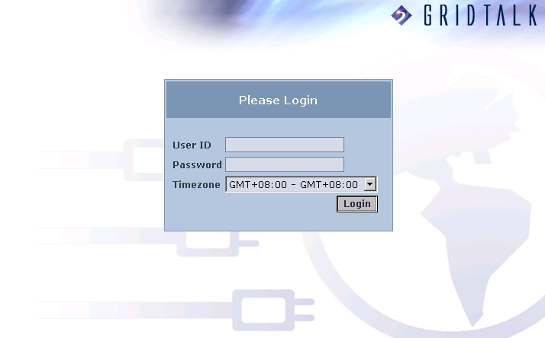

- Enter the user name.

- Enter the password.

- Select the Timezone. For information on the Timezone, refer to GridTalk 4.2 Administrator Guide.

- Click on the Login button. Then the browser will show the Registered page if you have already registered for service to GridTalk. After initial registration, you will normally see the Documents tab that displays the Import Document page by default during the next login. To explore how to use GridTalk, see Chapter 3 Using GridTalk User Interface.

Using GridTalk User Interface

The GridTalk application (“application” is a term used to describe a type of computer program) is accessed using a web browser. With the exception of the web browser software which is usually already installed on users (we use the term “user” to refer to a person who uses the “application”) computers, no additional client software (“client software” is software that is used to access a “server” application”. A server is a dedicated central computer that runs one or more “applications” that are accessed by many people at the same time) needs to be installed to access GridTalk. Upgrades to the GridTalk server will also not require any changes to be made to each client machine.

Your system administrator should have already ensured that your computer has a browser installed that is suitable for accessing GridTalk.

Browsers that may be used to access GridTalk are Microsoft Internet Explorer versions 6 and above and Mozilla version 1 and above, including Netscape version 7. (The Mozilla browser is free and may be downloaded from www.mozilla.org versions are available for most common operating systems including Microsoft Windows and Linux. The Netscape Browser may be downloaded from www.netscape.com and Microsoft Internet Explorer 6 may be obtained from www.microsoft.com - note however that you should check with your companies technical support before installing new software on your computer). Limited support is provided for Netscape version 6 but its use is not recommended. Microsoft’s “Internet Explorer” browser is usually installed as a standard application on computers that run Microsoft’s “Windows” operating system. As mentioned however, your computer should already be loaded with a suitable browser so it is most unlikely that you will ever need to install any additional software yourself to use GridTalk. If in doubt, please contact your company’s technical support.

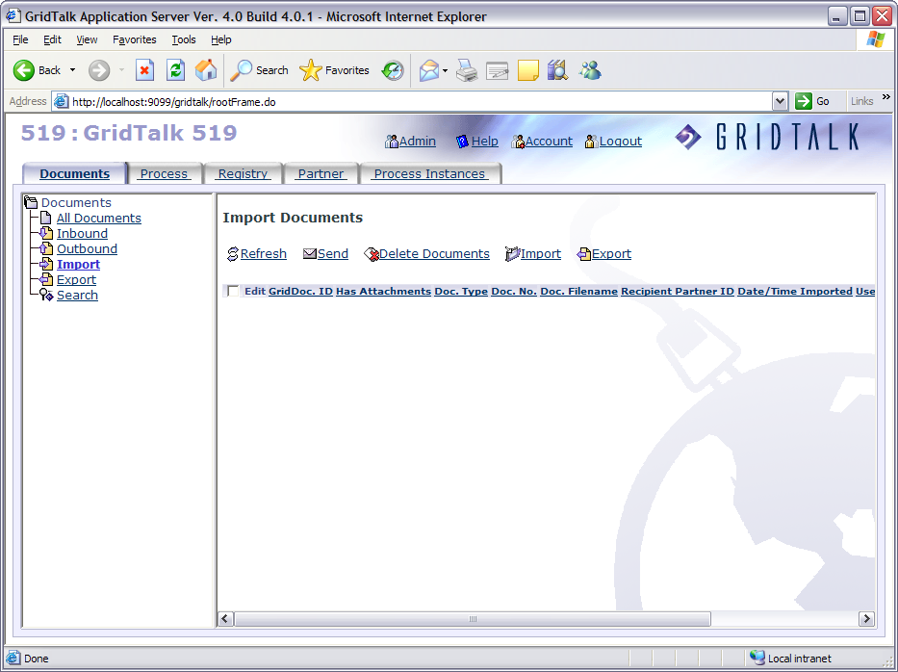
GridTalk Logo
GridNode ID & Name
Tabs
List View Page
Links
Navigation Panel

As illustrated, you will see your GridNode ID and name that are shown in the top left of the GridTalk application window. Your GridNode ID and Name will be shown only after your successful registration. In this section, the interface will be described per function.

Tabs

The tabs (such as “Documents”, “Process”, and “Registry” etc) are used to navigate between different pages of the application. Only one tab will be active at a time and the active tab is highlighted in a different colour.

The set of tabs shown depends on whether you are in the “admin” or the “user” area of the application. The admin area is generally used by administrators and in fact provides access to the same tabs as they are provided in the user area, with some addition of some extra tabs providing access to parts of the application used for configuration. To move between the user and admin areas, a link is provided.

Links

While using GridTalk, you will notice that some links are used on different pages to indicate common operations. A link is an icon or section of text that you may click on to navigate or invoke some kind of action. In GridTalk, these links are usually underlined to make it easy to identify them on the screen.

Here follows a list of the most commonly used links in GridTalk.

Link | Comment
Admin | Refers to the admin area of the application. When in the admin area, it will display “User” and clicking it will take you back to the user area.
Logout | The Logout link ends your GridTalk session and returns you to the Login page.
Refresh | This link is used to refresh the list view page with the most current information. For example, if another user edits one of the records, its details will not be updated until you refresh the list view or go to a different page and return.
Delete | This link is used to delete a record from the list view page. For more details, see Chapter 3.4 List View Page.
Create | This link is used to create a record to be added in the list view page. For more details, see Chapter 3.4 List View Page.
Save | This link is used to save the changes that you have made to the record. For more details, see Chapter 3.5 Detail View Page.
Cancel | This link is used to exit the Detail View Page without editing anything to a record. For more details, see Chapter 3.5 Detail View Page.
 | This link is used to create an item in the Detail View Page.

Navigation Panel

The navigation panel presents a hierarchical list of links to various functions of the application. An example of a function can be a certain list view page or other types of screens like Company Profile page, etc. Clicking (single clicking) the underlined text causes the associated screen to be displayed in the panel on the right. The links that are displayed in the navigation panel depend on which of the available tabs at the top of the screen is selected. The tabs are selected by clicking them (a single click), and it can take a second or two for the new screen to be displayed.

Some links have a small plus (+) sign in a little box next to them. You can click on this plus sign to reveal hidden links. You will notice that when you move the mouse pointer arrow over the symbol, it will itself change to indicate that this is clickable. Unlike the hand symbol used for links, a plus symbol will be shown. Like links, these objects require only a single click to activate. Once expanded, the plus symbol will change to a minus symbol (-) to indicate that another click will hide the revealed links again.

The following series of screenshots illustrates this. Here we are clicking on the plus sign to the left of the “Communication Profile” link. We have already clicked the link itself and in the main panel in the screenshot below you will observe that the list view shown is for “All Communication Profiles”

When you click the plus symbol for the “node” in the tree, its “children” are displayed:

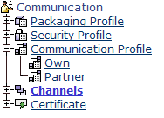

All these nodes are listed beneath “Communication Profile” and like the “Communication Profile” node, they link to the list view of Communication Profile records – however rather than showing all the records, they narrow down the list to a subset of the records. The “Partner” link will cause the list of all Partner Communication profiles to be displayed in the list view page.

In the navigation panel for some other tabs, you may see that the “child nodes” are themselves expandable. As you might expect, clicking it will reveal more nodes with links:

List View Page

List view pages present a list of records of the same type. GridTalk has many types of records. Some are associated with your company’s documents, but the majority of the records in GridTalk are configuration information used to define the processes that GridTalk performs on your company’s documents, to define the partners your GridTalk communicates with, and the methods it uses for such communication. Regardless of the record type the list views in which the records appear all have much the same features.

Presented below for your inspection is a typical list view:

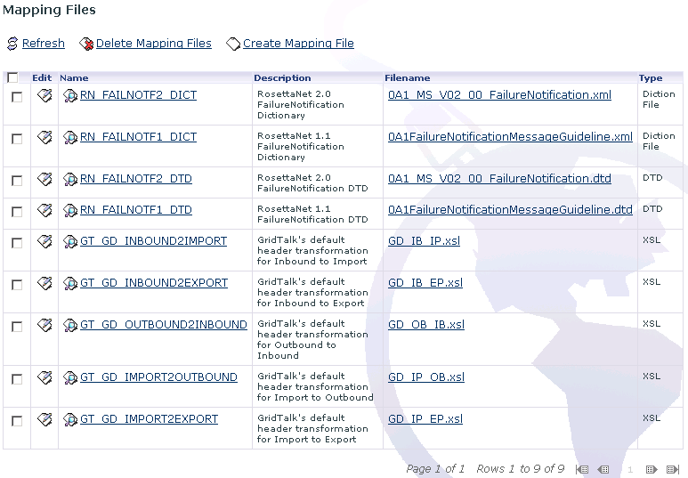

At the top of the page is a heading that indicates what types of records are contained in the list view. In this case “Mapping Files”. Each row in the table corresponds to a single record.

The names of the columns are shown in the table header, and these names correspond to fields in the record. The first column is labeled “Edit” and each row contains an image. This image is a shortcut that you may click to open the record for editing. When you open a record for editing, its “detail view” will usually appear in a new browser window. . (The use of detail views will be explained later).

The first column after the Edit column contains an image and some text that is underlined. The contents of this column are also a link, in this case to allow you to open the record for viewing in a new detail view window.

For some records, the contents of other columns may also be underlined. There are some cases in which this occurs. The first is when the field of the record to which that column corresponds contains a reference to another record, in which case the link will open a detail view of the record referred to in a new window. The second case is where the field contains a file. In this case clicking the link will allow you to either open the file in a new browser window for viewing or download the file to your computer – this depends on the type of the file and the way in which your web browser has been configured.

Above the table are three links. These links (Refresh, Delete, and Create) are standard for most list view pages. Some list view pages have more links where there is a specialized functionality, while some do not show all three of the links.

The first link, “Refresh” is used to refresh the list view with the most current information. If for example another user edits one of the records, its details will not be updated until you refresh the list view or go to a different page and return. For some record types, such as Documents new records might be coming in from an external source, and clicking Refresh will update the list view to show any new records. (This Refresh link works differently to the refresh button provided by your browser. As mentioned earlier in the documentation you should avoid using the browsers refresh button in GridTalk due to the dynamic nature of the GridTalk application. If the documentation asks you to refresh a list view, it means you should use the Refresh link that is provided on the list view page).

The second link provided is Delete. The delete link allows you to remove records from GridTalk. The type of record to be deleted is also indicated by the text of this link. In the screenshot presented it reads “Delete Mapping Files”. Not all records may be erased, and for some list views, the delete link might not be present. To delete a record, or a set of records, they need to be selected. You will note that the leftmost column of the table contains small boxes, with one for each row. These are known as “Checkboxes”. When you click on a checkbox, a tick will appear in it. Clicking a checkbox that has a tick will remove the tick. The checkboxes in the list view page allow you to select a record or group of records. In addition to the checkbox being checked the row in the table will change color. To delete a group of records, you select those records that you wish to delete and having done so click Delete, at which point you are presented with what is called a “dialog box” which asks you to confirm that you really wish to delete the specified records. If you did not intend to click delete or you realize that you have selected an incorrect record, you may back out at this point by clicking the “Cancel” button. Clicking “Ok” will cause the delete operation to proceed.

The screenshot below shows some “Partner Type” records being selected for deletion:

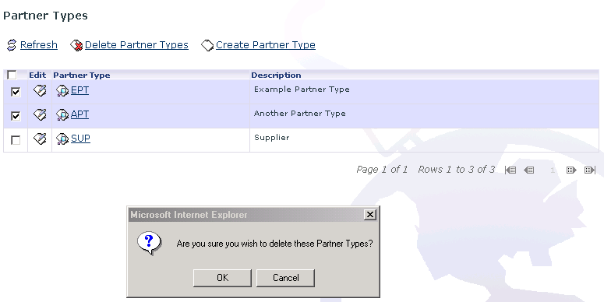

You have probably noticed that in addition to the checkboxes in each individual row of the table, there is also one in the header of the table to the left of the column names. This checkbox allows you to select all the rows on the current page of the list view (we will explain more about list view paging shortly). If no records or some but not all records are selected, then clicking the select-all checkbox will cause all records to be selected. However, if all the records are already selected, then clicking the select-all checkbox will cause all to be unselected.

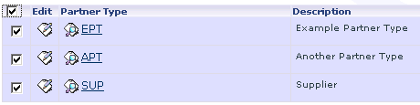
As mentioned above, not all records can be deleted. If, for some reason, a record cannot be deleted and you try to delete it, GridTalk will report this to you in an error message. (Any records in the group you selected that could be deleted will have been deleted by the time you see this message telling you about that ones that could not be erased). An example of this is presented in the screenshot below:

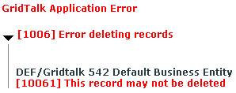

(In this screenshot, the “Business Entity” record could not be deleted, as it is a record that is needed for the correct operation of GridTalk. GridTalk created this Business Entity automatically when the GridTalk administrator registered the application. Certain configuration records of various types are also preconfigured into GridTalk and may not be deleted).

The other reason why we are not allowed to delete a record is that otherwise the GridTalk configuration would not be in a consistent state.

Below is presented an example screenshot that illustrates the error shown when you try to delete a record that has other records referring to it. We call such records “dependencies” as they “depend” on another record.

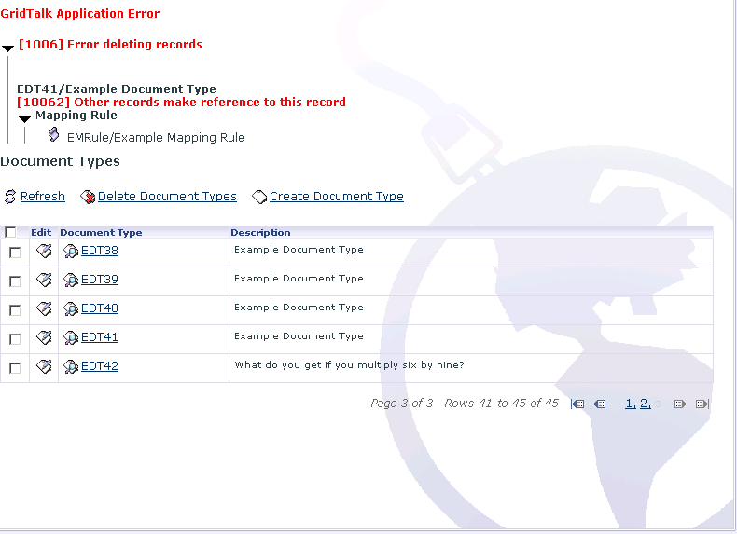

If there is more than one record that cannot be deleted from a group that you select, then each will be indicated individually in the error message. Where there are dependencies the types of dependant record, and the descriptions of each individual dependent record are also provided.

One point to note about the error messages is the little black triangles. These triangles may be clicked to hide or reveal details in much the same manner as the plus symbols in the navigation tree may be clicked to hide or reveal child nodes. When the error is presented to you, the triangle may be pointing to the right, in which case you will need to click it to reveal the hidden “section” containing further details.

The third link in the trio of links located above the table is Create. Like the delete link, it also specifies the type of record to be created. When you click on it, another browser window will open containing a “detail view” of a new instance of that record type.

The final elements of interest in the list view are those that relate to paging. To cut down on network traffic and server workload, the list views that have a lot of records are broken up into a number of pages. The paging tools are found below the table of records. The current page and the number of pages are shown, as the range of records this relates to. The number of records that show on a page is usually 10, however your GridTalk administrator may have configured a different number.

To the right of the text displaying the current page information are some arrows, and between the two sets of arrows are some page numbers. These page numbers are all links, with the exception of the one relating to the currently displayed page in the list, which is grayed out. As would be expected, clicking the number will take you to that page. Of the arrows the outermost will take you to the first and last pages, while the inner arrows will take you to the previous and next pages respectively. If you are on the first or last page, two of the arrows will not be clickable and will be grayed out.

Detail View Page

In general, when you choose to edit or view a record presented in a list view, its detail view will open in a new window. This allows you to open multiple detail view pages so that you may examine and edit more than one record at once. Certain detail view pages will be shown in the main panel of the screen however. The “Company Profile” detail view page is one example.

A detail view page may be in one of two modes, that is, View or Edit. Here is an example of a typical detail view in view mode:
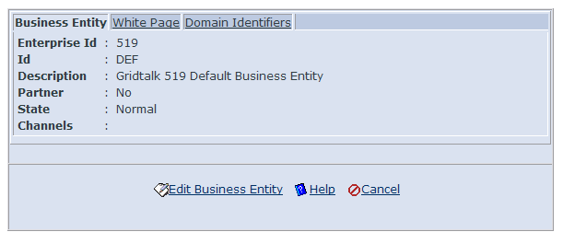

You will note the Edit link at the foot of the page in the screenshot above. If the record is one that you are allowed to edit, then this link will be provided. Clicking it will place the record into the edit mode. The following screenshot is from the same record in the edit mode:
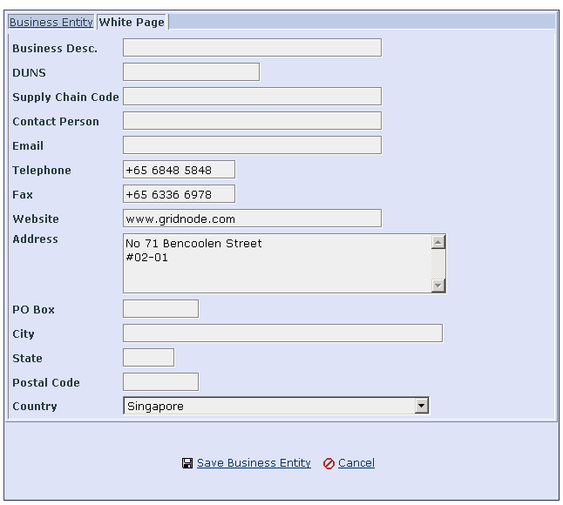
At the foot of the detail view in edit mode is a Save link. Clicking this will save the changes that you have made to this record. Changes you make are not stored in the system until you save them. After saving the record the detail view will close. If it is in its own window and you did not “divert” to this page then this will close the window (more will be said about the process of diversion shortly) otherwise if the detail view is in the main panel then in most cases you will be returned to the page that took you to this detail view.

Common to both edit and view mode is a Cancel link. Like save, cancel will close the detail view; however changes that you made to this record will not be stored.

Some detail views (such as the one in the screenshot above) make use of tab panels to organize their content. The currently visible tab is highlighted – in the example above this is the “White Page” tab. To move between tabs, simply click the tab you wish to switch to.

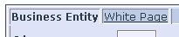

If you are viewing the detail view in its own window then closing this window manually will have a similar effect to cancel. When you do this you may notice a small window opening temporarily. This window is used to send information to the server telling it that you closed the detail view window. Unlike using the cancel link, closing the detail view window manually will not return you to the previous page of a diversion sequence, so you are advised to get into the habit of using the cancel link to exit detail views.

We use the term diversion to refer to the mechanism by which you can while creating or editing one type of record, divert to another page to create a new record of another type that you need for the first. During this diversion the changes that you made to the first record are not updated in the system, but they are remembered, so that upon return from the diversion you may continue editing where you left off. Diversions are usually activated by a link next to or below a field that refers to another record. This can be seen in the screenshot below:

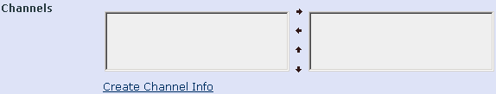

Here we see the ‘channels’ field from the detail view of a “Business Entity” record. Business Entities can have one or more related “Channel” records. Below the channels field is a link that will allow you to divert to the Channel detail view to create a new channel. When you save (or cancel) the editing of this new channel it will be stored and you will be returned to the Business Entity detail view. Any changes you made to the business entity record before diverting will still be present, and the new channel will also be available for selection.

Diversions may themselves be diverted from. Returning to the example above, if you had diverted to the channel detail view to create a new channel you would as part of that process need to specify a “Communication Profile” for the channel to use. If there was not already a suitable communication profile you could divert again using the link provided and create one. On completion you would be returned to the channel detail view, and having completed that, returned back to the business entity detail view.

Normally detail views are presented in their own window. Unlike the cancel link, closing the detail view window will not return you to any pages you had diverted from, and so the changes you made on such pages will be lost. (Only those records you had already explicitly saved already will be updated in the system – although for certain types of records that have very closely related child records this may not be the case – one example being the workflow activities associated with a partner function. Where this is the case it will be noted in the documentation for that record type).

When the detail view is presented not in its own window, but rather in the main panel, use of the navigation tabs and the links in the navigation tree will act in a similar manner with regards to diversion as closing the window would for a detail view in its own window. In this case however you will be prompted as to whether you wish to abort the operation. Again, only changes to records that you have explicitly saved will be updated in the system.

When editing a record, some fields must be given a value. These fields are known as “mandatory” fields. Mandatory fields are displayed with a different shade of colour in their background to make them more recognisable. For example in the following screenshot the Command File Dir and Command File fields are mandatory while the Command Line field is not:

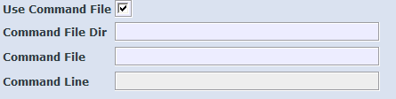

If you try to save the changes and there are mandatory fields that have not had a value specified, the changes will not be saved, but rather the page will be redisplayed, with the addition of error messages next to those fields that needed a value and did not have one. An example is shown in the screenshot below. Here we have tried to save a record without filling in details for one of the mandatory fields:

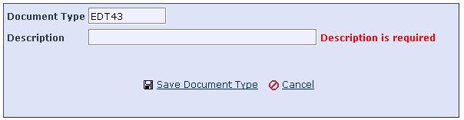

Other types of validation error are also possible, for example when you enter a value that is of the wrong type or outside the allowed range. These errors will also be displayed next to or above the field in question.

Until you provide input that satisfies the forms validation constraints, you will be unable to save the changes.

Many fields require you to choose from a list of options, or to enter certain fields, however the options that appear, or the fields that must be entered, depend on the value you provide for another field. Where this is the case, when you change the value of the field on which these options depend, the page will be refreshed from the server. You will see the “Communicating with GridTalk server” message appear momentarily and then be returned to the page with the appropriate fields, options, etc. available for use.

Fields

Various types of field are used in GridTalk’s Detail View pages to allow you to enter information into the system, for example, the Login page.

Text Fields

Text fields are boxes into which you may enter text. To do so, position the mouse pointer arrow over the box and click. A cursor (flashing bar or box) will appear at the position you clicked and what you type will appear at this position in the text field.

Drop Down Select Boxes

A drop-down Select Box provides a list of values for you to choose from. To do this, click the small arrow at the right side of the box. This will cause the list of choices to be displayed. Click the choice you want.

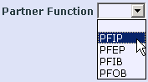

Checkboxes and Radio Buttons

A checkbox is a small box that may contain a checkmark. Checkboxes may be in one of two states: checked or unchecked. Usually a checked value will correspond with a “true” or “yes” meaning. To change the value of a checkbox, simply click the box. If it is checked, the check will be removed. If it is not checked, it will become checked.



Radio buttons are similar to checkboxes, but they work as a group. They are usually rendered with a round shape by most browsers. Among a group of radio buttons, only a single radio button may be checked at any one time. When you click the radio button corresponding to the option you want, the previously selected radio button will be unchecked.

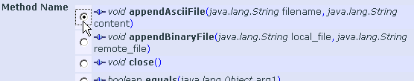

Multi-selector

The multi-selector is a tool to allow you to select multiple options from a list of choices. For some fields it also provides you with the ability to set the order of the choices. The multi-selector is presented in the form of two boxes with some arrows. The box on the left contains the list of options that you may choose from, while the box on the right contains the list of options that you have chosen. You may click on options in either box and move them to the other box by clicking the appropriate arrow. Where the field allows you to select the order of the options you have chosen you may use the up and down arrows to achieve this. If you wish to highlight more than one item in the list at a time, you may hold down the CTRL or SHIFT key while clicking.

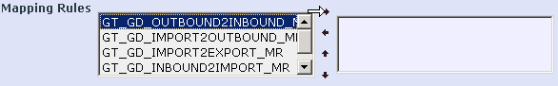

Files

Some fields allow you to store files. These fields consist of a text box, a browse button and a link entitled “Add/Remove Files”. If the field already has files in it, then their filenames will be displayed with a checkbox next to each file’s name.

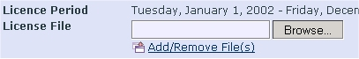

To add a file to the field, click the Browse button. A dialog box will appear to allow you to select the file to be added. Having selected the file, you will note that its full path will appear in the text box to the left of the Browse button. Click Add/Remove Files and the page will be refreshed. The length of time taken depends on the size of the file that was selected, as its contents must be transmitted to the server from your computer. When the page reappears, you will see the name of the file with a checkbox to the left of it.

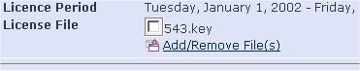

Not all file fields allow more than one file to be stored. If this file field only allows one file, the textbox and the Browse button will not reappear. For those that do allow multiple files, the textbox and Browse button will still be available, and you may repeat the process to add additional files to the field. For example, when you import files in the Import Document detail view page.

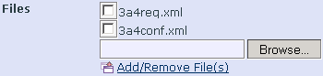

To remove files from the field, click the checkboxes of those files that are to be removed and then click Add/Remove Files. You may add a new file and remove existing ones at the same time.

Embedded List Views

Some Detail View pages contain one or more “embedded” list views. These embedded list views function in a similar manner to normal list views but are usually used for managing child records of a parent record. Unlike a normal list view, the View, Edit, and Create links of an embedded list view make use of the diversion mechanism rather than opening new windows. Embedded list views also lack a paging mechanism or an explicit refresh link.

In some cases, an embedded list view allows you to change the order of its rows by providing Up and Down links. Clicking these links will move the selected records in the embedded list view up or down relative to the unselected records.

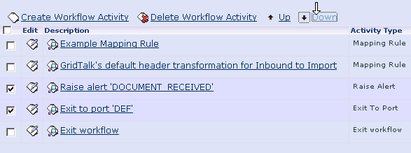

Registry

The users can use the Registry feature to (i) manage business entities based on their profiles; (ii) update the company profile; (iii) manage partners and so on.

As shown in the figure, this feature provides the following functionalities:

- Company Profile - View and update your own company profile
- Business Entities - Manage business entities

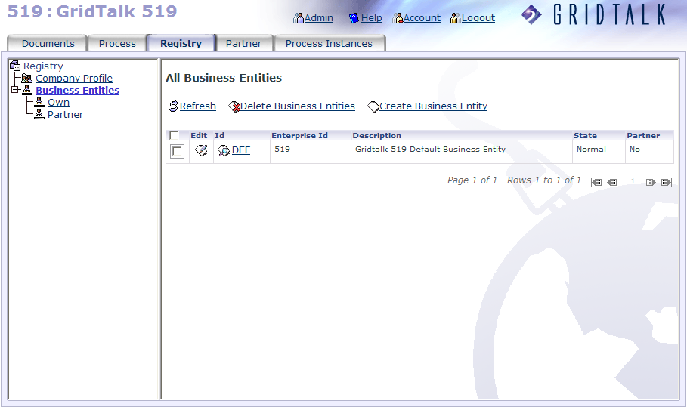

Viewing and updating the Company Profile
The Company Profile is the information viewer tool to edit your company profile as well as to let your partner browse your profile and contact you.

To view your company profile

- Click Registry.

- To view your company profile, click Company Profile under the Registry folder. Then you will be taken to the screen where you can view details that were earlier entered during registration.

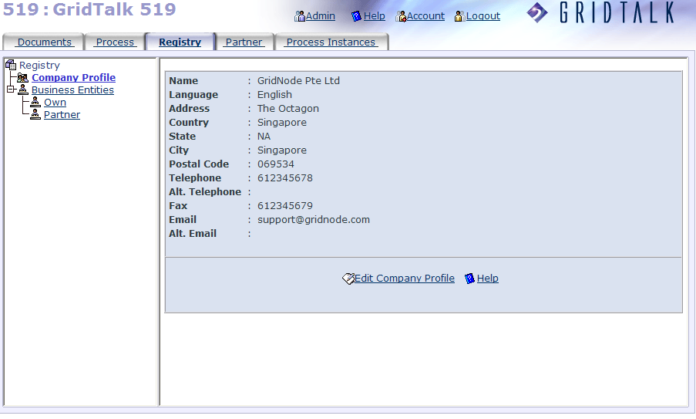

- If you wish to edit your company profile, click Edit Company Profile. The browser takes you to enter any of the required fields in the Company Profile pane. Take note that the Name, language and Country are mandatory. All the other fields are always optional unless required.

- To save the new changes, click Save Company Profile.

Managing business entities

Your GridNode ID is a unique identifier for your registered copy of GridTalk. However, different users may deploy GridTalk at different levels of their enterprises. A company may be using a single GridTalk, or each department within the company may have its own copy of GridTalk, each with a different GridNode ID. Alternatively, a group of related companies may be using just one GridTalk.

For this reason, you will need to define the business entities associated with your copy of GridTalk to facilitate the information flow. At minimum, each copy of GridTalk must be associated with at least one business entity. The definition of a business entity may vary according to the user’s needs and company structure, but can basically be imagined to be a single enterprise or any sub-division thereof – e.g., a department.

A business entity describes the organization or group, which a user belongs to. A business entity belonging to a trading partner company is associated with one or more partners, and channels that serve as the communication channel to the partners in that business entity.

The white page is provided to describe the business details of the business entity

To view a list of all business entities

Click Business Entities. The browser will bring you to the All Business Entities panel where you should see a list of own and partner business entities that have been earlier created. The following columns in the header of the All Business Entities table are displayed:

Edit:
This field allows you to update the details of your own or partner business entity.

Id:
This field identifies the Business Entity.

Enterprise Id:
This field is actually your own GridNode ID. If it is not specified, it means the business entity belongs to a partner.

Description:
This field describes the purpose of your own or partner Business Entity.

State:
This field indicates the state of your own or partner Business Entity.

Partner:
If the partner checkbox is ticked, it means that the business entity will be in the Partner Business Entity list itself. Otherwise it will reside in the Own Business Entity list.

To create a own business entity

- Click Registry.

- Click Own under the Business Entities folder. This will display a list of all previously defined own business entities in the Own Business Entities list table.

- To create a business entity, click Create Business Entity. The browser will bring you to the Business Entity tab.

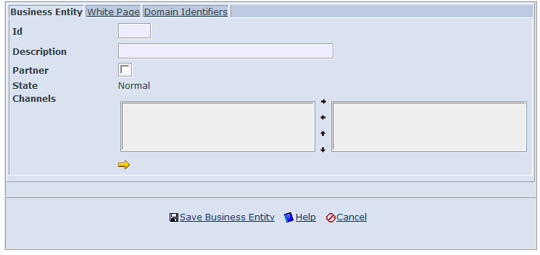

- Enter the following fields:

Id:
This field identifies the Business Entity.

Description:
This field gives a description for the Business Entity.

Partner:
This checkbox indicates if it is your own or partner Business Entity. If un-ticked, it means you are creating Own business entity.

State:
This field is non-editable. Just leave it as it is.

Channels:
This field is actually the channels you use for sending/receiving documents. For own business entity, this may be left blank.

- Go to Channels. Select the channel for that business entity. If you select more than one channels, organize them using up and down arrow buttons. However, if the channel you want to select is not found in the Choice listbox, click on the icon to create a new channel. (Refer to Chapter 7.1 for creating a channel in GridTalk 4.2 Administration Guide).

- Next go to the White Page pane to complete the necessary fields.

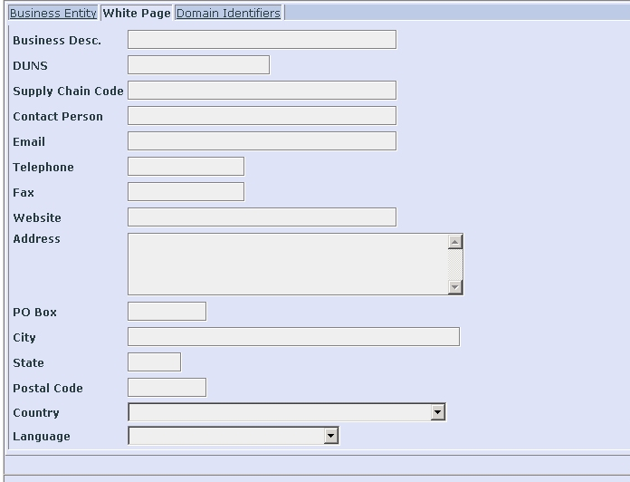

- Once done, proceed to click on the Domain Identifiers tab. To add a domain identifier, just click on the Add Domain Identifier link in the detail list page. From here, you can select the available types such as AS2 Identifier, Discovery Url, Duns Number or Global Location Number. Then you enter the corresponding value that relates to the type you have selected. If you wish to delete a domain identifier, tick the checkbox next to the Domain Identifier and click the Remove Domain Identifier link.

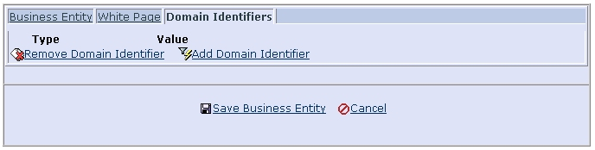

- Click Save Business Entity. The new business entity will be displayed in the All Business Entities table.

Note: If the checkbox of partner is ticked, the business entity will be displayed in the Partner Business Entities list, else the newly created business entity will also appear in the Own Business Entities list.

- To add more business entities, repeat the whole procedure. If you want to view the business entity, go to the All Business page where you will see the records listed in the table. Click on the selected business entity’s hyperlink under Id in the table. If you wish to update the select business entity, click Edit Business Entity.

- To edit your Own Business Entity, click on the Edit button next to the business entity you have just selected. The screen appears. Update the entries of the business entity as necessary. Then click Save Business Entity to save the changes.

To delete a business entity

- Click Registry.

- Click Own under the Business Entities folder.

- In the Own Business Entities list, select the check box of the business entity you want to delete.

- Click Delete Business Entities. The selected business entity will be removed from the list.

To create a partner business entity

- Click Registry.

- Click Partner under the Business Entities folder.

- In the Partner Business Entities list view page, click Create Business Entity.

- In the Business Entity detail view page, insert the necessary fields. The two fields, Id and Description, which are highlighted blue, are mandatory. Make sure to tick the Partner checkbox. For other fields such as Channel, White page, Domain Identifiers, etc, follow the similar procedure as that one when creating own business entity.

- Click Save Business Entity. The new business entity will be displayed in the Partner Business Entities list.

- To edit the existing or current partner business entity, click on the Edit button next to the business entity you selected. Update the entries of the business entity as necessary. Click Save Business Entity.

- To delete the existing or current partner business entity, tick the check box of the business entity you want to delete. Click Delete Business Entities. The selected business entity will be removed from the list.

Partner

As a user, it is unlikely that it will be useful to define the recipients of the documents that you want to send out simply by their Business entity ID. It is more appropriate to let the user map the recipients to identifiers already known to the company. For example, identifier used in the backend ERP system.

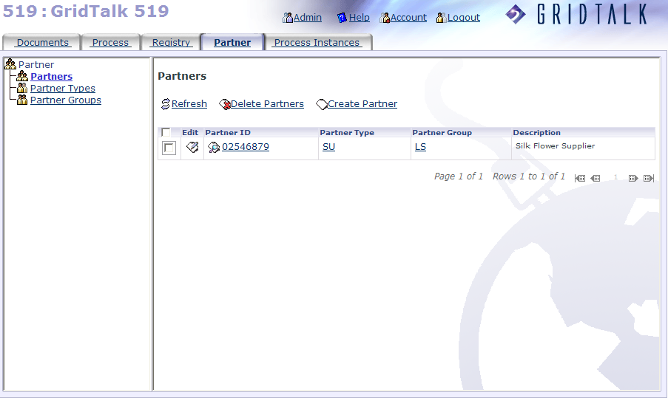

Each partner is defined by a number of parameters:

Partner ID
This may be a number or a combination of characters and symbols. If you have a back-end application such as an ERP system, the partner IDs may already have been generated by this application.
For example: 0000001000
Using an ID that has been pre-generated by a back-end application will help GridTalk to automate the sending process for documents created by this application.

Partner Name
This is the name of the enterprise or even department that you exchange documents with.
For example: Compass Inc.

Partner Type
This is a classification of the broad type to which the partner belongs, based on its dealings with you. The GridTalk administrator should define the partner types.
For example: Supplier

Partner Group
This is a classification of the broad group to which the partner belongs, based on its dealings with you. The GridTalk administrator should define the partner groups.
For example: Local Suppliers

Managing Partners

A Partner in defined in GridTalk may be in one of these 3 states: Enabled, Disabled, and Deleted. An Enabled Partner is one that is active for your business connection; a Disabled Partner is one that is not yet in your business connection network or temporary not in connection with your company; a Deleted Partner is one that you no longer keep contact with and would not have any future business transactions using its identity. Nevertheless, GridTalk still hold the deleted partner in database record for your future reference. When creating or updating a partner configuration, you may either set the state of the Partner to Enabled or Disabled. A partner’s state will only before Deleted when you use the Delete Partner function.

To create a partner

- Click Partners under the Partner in the Selection tree. The Partners list view page is displayed.

- To create a new partner, click Create Partner. The Partner detail view page appears.

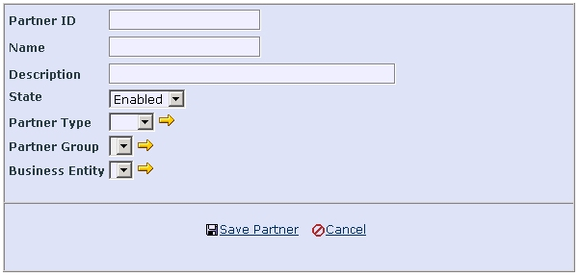

- Enter the necessary fields.

- Select State. Then select Partner Type. If the partner type you want to select is not listed, click on the icon to create a new partner type. (Refer to Chapter 5.2 for creating a partner type).

- Next select Partner Group. If the partner group you want to select is not listed, click on the icon to create a new partner group. (Refer to Chapter 5.3 for creating a partner group).

- Proceed to select Business Entity. If the business entity you want to select is not listed, click on the icon to create a partner Business Entity (Refer to Chapter 4.2 for creating a business entity).

- Select Default Channel displayed based on the Business Entity you have selected. This will show those channels assigned to the selected Business Entity. Default Channel means the channel to use by default for non-RosettaNet transactions.

- Click Save Partner. The new partner will be displayed in the list table of the Partners page.

- To add more partners, repeat the whole procedure. If you want to view the partner, go to the Partners page where you will see the records listed in the table. Click on the selected partner’s hyperlink under Partner Id in the table. If you wish to update the selected partner, click Edit Partner.

- To edit the existing or current partner, select the partner and then click on the corresponding Edit button. Update the entries of the partner as necessary. Click Save Partner.

- To delete the existing or current partner, tick the Select checkbox of the partner you want to delete. Click Delete Partners. The selected partner will be removed from the list. Take note that the deleted partner ID could not be re-used. Subsequent creation of partner using an ID of a deleted Partner will be rejected.

Managing partner types

Partners should be classified into types based broadly on their relationship with your enterprise. Examples of partner types are supplier, customer, logistics, warehousing or bank.

To create a partner type

- Click Partner Types under the Partner folder. The Partner Types list view page is displayed.

- To create a new partner type, click Create Partner Type. The Partner Type detail view page appears.

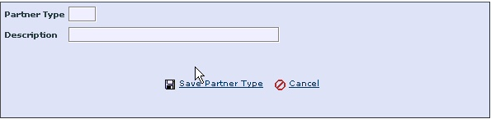

- Enter Partner Type.

- Enter Description.

- Click Save Partner Type. The new partner type will be displayed in the list table of the Partner Types page.

- To add more partner types, repeat Step 2 through Step 5. If you want to view the partner type, go to the Partners page where you will see the records listed in the table. If you wish to update the select partner type, click Edit Partner Type.

- To edit the existing or current partner type, select the partner type from the list table and then click on the corresponding Edit button. The Partner Type page shows its details to be updated. Update the entry of the partner as necessary. Click Save Partner Type.

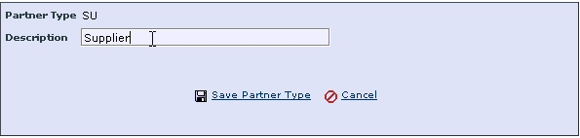

- To delete the existing or current partner type, tick the blank Select checkbox of the partner type you want to delete. As you see a mark in the checkbox of the highlighted partner type, click Delete Partner Types. You will be prompted with the message box asking, “Are you sure you wish to delete these Partner Types?” To confirm the deletion, click OK. The selected partner type will be removed from the Partner Types list table.

Managing Partner Groups

Partner groups should be created based on the need for further sub-division of the existing partner types.

To create a partner group

- Click Partner Groups under the Partner folder. The Partner Groups list view page is displayed.

- To create a new partner group, click Create Partner Group. The Partner Group detail view page is displayed showing the empty fields.

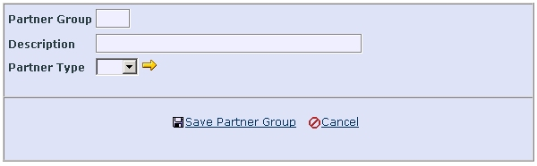

- Enter the mandatory fields such as Partner Group and Description.

- Select the partner type using the drop down arrow button next to the Partner Type field. If the partner type you want to select is not found in the list, click on the icon to create a new partner type. (Refer to Chapter 5.2 for creating a partner type).

- Click Save Partner Group. The new partner group will be displayed in the Partner Groups list table.

- To add more partner groups, repeat the whole procedure. If you want to view the partner group, go to the Partner Groups page where you will see the records listed in the table. Click on the selected partner group’s hyperlink under Partner Group in the table. If you wish to update the selected partner group, click Edit Partner Group.

- To edit the existing or current partner group, select the partner group and then click on the corresponding Edit button. The Partner Group page is displayed. In the Partner Group page, update the entry of the partner as necessary. Then click Save Partner Group.

- To delete the existing or current partner group, tick the blank Select checkbox of the partner group you want to delete. As the mark appears in the checkbox of the highlighted partner type, click Delete Partner Groups. You will be prompted with the message box asking, “Are you sure you wish to delete these Partner Groups?” Then click OK. The selected partner group will be removed from the Partner Groups list table

Documents

The Documents feature is designed to manage imported, exported, inbound and outbound documents in their respective folders.

GridTalk maintains a set of information for every business document that it handles. This information allows GridTalk, among other things, to track the movement of the business document, identify the source and destination of the business document, and to provide time stamping. This provides a full audit trail for any document handled by GridTalk.

This set of information is recorded in an XML-based document known as the header document or GridDocument (abbrev. GridDoc. or GDoc.). The GridDocument not only contains the audit information and the information required by GridTalk for sending, but the actual business document itself is also embedded within the GridDocument.

The information kept within GridDocument will be displayed in the application view (e.g. Excel, MS Word, Internet Explorer, etc) when you click on the entry for that document under the GridDoc. ID column. When viewing the document details page, the information is arranged into five tabs such as General, Traceability, Partner, Communication and Attachment.

Understanding Information about a Document

The following sub-sections describe the detail information that GridTalk provides on the business documents that go in and out of GridTalk. The detail information about a document is accessible from a document list view page by clicking on the GridDoc. ID column of the particular document you are interested in viewing the detail information.

General Information

Clicking on the General tab pane displays the data in the General and Embedded sections.

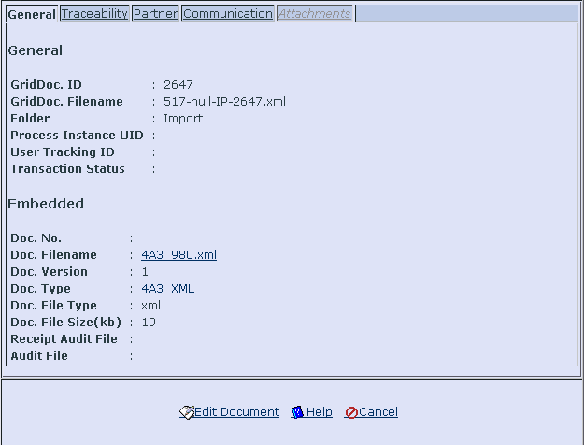

The General section contains the general information kept within GridDoc. It is used for tracking and audit purposes. Most of the information is generated by the system. The fields are explained in the table below:

Field | Description
GridDoc. ID | Unique ID number in each Document Folder used for tracking purposes
GridDoc. Filename | Filename of the GridDoc
Folder | Document folder (if any) of the business document
Process Instance | Process Instance ID of the process the business document participates in (applicable for Inbound, Outbound and Export documents).
User Tracking ID | User tracking identifier extracted from the business document if any.
Transaction Status | Transaction status of the business document. For example, it will show the processing status of an Inbound or Outbound AS2 document.

The Embedded section contains information about the business document.

Field | Description
Doc. No | Document number (if any) of the business document
Doc. Filename | Filename of the business document
Doc. Version | Version (if any) of the business document
Doc . type | Document type (as defined by user) of the business document
Doc. File type | File type of the business document, e.g., CSV file
Doc. File Size (kb) | File size of the business document
Receipt Audit File | Filename of the received audit document. For example, it will capture the filename of the returned AS2 MDN from the partner.
Audit File | Filename of the audit document.

Traceability Information

Clicking on the Traceability tab pane displays the data in the Traceability and Partner Function sections.

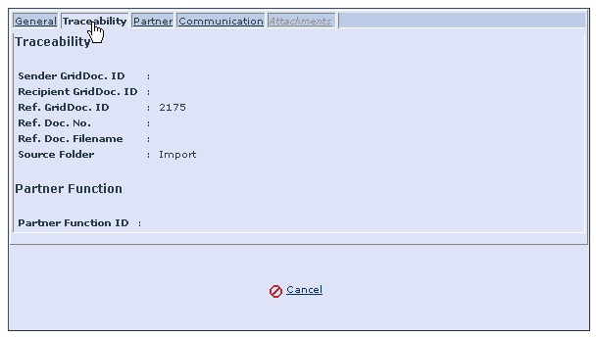

The Traceability section contains the information used by GridTalk for synchronization and reconciliation of documents during the workflow process. This information is useful when you receive back a document that has been created based on a source document that you sent out, and you need to refer back to that source document to process it.

Field | Description
Sender GridDoc. ID | GridDoc ID of the business document at the sender
Recipient GridDoc. ID | GridDoc ID of the business document at the recipient (if known)
Ref. GridDoc. ID | GridDoc ID of the reference GridDoc document ( if any) (the source GridDoc)
Ref. Doc. No | Document Number of the reference business document
Ref. Doc. Filename | Filename of the business document that is the source of the reference document
Source Folder | Indicates where the business document flows from Import Folder of the reference document

The Partner Function section contains information about the partner function that is triggered to handle the document.

Field | Description
Partner Function ID | Partner Function ID of the partner function that handles the business document.

Partner Information

Clicking on the Partner tab pane displays the data in the Sender and Receiver sections.

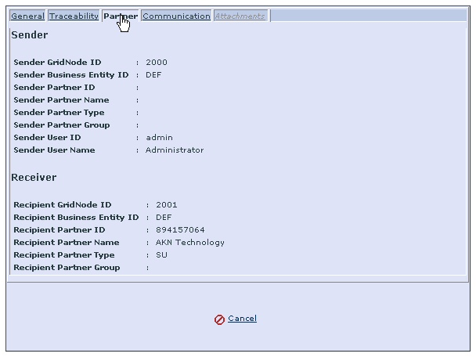

The Sender section contains the information about the sender of the document. Note that this information will only be present after the document has been received in the Inbound folder and will primarily be displayed for the receiver, rather than the sender.

Field | Description
Sender GridNode. ID | GridNode ID of the sender partner if any.
Sender Business Entity ID | Business Entity ID of the sender derived from the sender’s User ID
Sender Partner ID | Sender’s partner ID as defined by the receiver
Sender Partner Name | Sender’s partner name according to the receiver’s definition
Sender Partner Type | Sender’s partner type defined by the receiver
Sender Partner Group | Sender’s partner group according to the receiver’s definition
Sender User ID | User ID of the sender
Sender User Name | User Name of the sender

The Receiver section contains the information about the receiver of the document. Note that this information will only be present after the document has been sent in the Outbound folder. It will primarily be displayed for the sender, rather than the receiver.

Field | Description
Recipient GridNode. ID | GridNode ID of the receiver partner if any
Recipient Business Entity ID | Business Entity ID of the receiver
Recipient Partner ID | Receiver’s partner ID as defined by the sender
Recipient Partner Name | Receiver’s partner name according to the sender’s definition
Recipient Partner Type | Receiver’s partner type defined by the sender
Recipient Partner Group | Receiver’s partner group according to the sender’s definition

Communication Information

Clicking on the Communication tab pane displays the data in the Communication, Channel, Routing and Port sections.

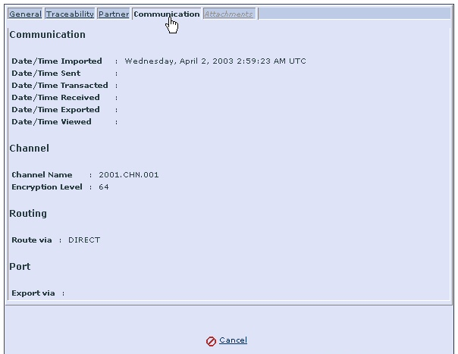

The Communication section contains the date and time details when the documents have been exchanged between trading partners.

Field | Description
Date/Time Imported | Date and time when the document was imported into GridTalk
Date/Time Sent | Date and time when the document was sent to the receiver
Date/Time Transacted | Date and time when the transaction was completed
Date/Time Received | Date and time when the document was received from the sender
Date/Time Exported | Date and time when the document was exported out of GridTalk
Date/Time Viewed | Date and time when the document was viewed by the user

The Channel section contains information about the sender’s or receiver’s channel when exchanging documents.

Field | Description
Channel Name | Name of the channel used for sending/receiving document messages
Encryption Level | Level of encryption set to ensure the security of the document messages received from/send to partners.

The Routing section contains the information which indicates whether the document is directly routed from / to partner or routed via GridMaster.

Field | Description
Route via | If the document is directly routed to partner, the field will show DIRECT. It tells you that the document is sent to the partner when the partner is online.

The Port section contains information about the port used to export the business documents out of GridTalk.

Field | Description
Export via | Type of port to send documents to the desired destination or to the backend system such as SAP

Attachment Information

Clicking on the Attachments tab pane displays the Attachments section as shown below.

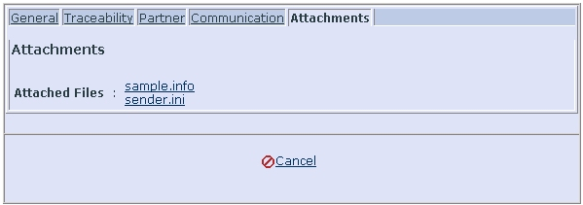

The Attachment section contains the list of the attached files when you and your trading partners engage in the business document process.

Field | Description
Attached Files | List of the filenames of the attachments to the business document.

Managing Documents in the Import folder

When you need to send a document to your partner, you may do so only by importing the document into GridTalk. Once the document is imported, it may either flow to the Outbound or Export folder depending on the partner function processing configured for that type of document and/or partner. Once in the Import folder, you may perform import, manual send, manual export, view and delete operations on the documents.

To view the import folder

Click Import under the Documents folder in the navigation pane. This will bring you to the Import Documents folder where you can import, send and delete business documents in the import folder.

The columns in the table represent the following information:

GridDoc ID:
It is the unique ID number in the Import Folder used for tracking purposes.

Has Attachments:
Indicates whether the business document has any files attached. If Yes, it means the business document has attached files. If No, the business document has no attached files.

Doc. Type:
Type of the business document. For example, 3A4 Purchase Order Request, Unclassified, etc.

Doc. No:
Document number (if applicable) of the business document.

Doc. Filename:
Filename of the business document. For example, PO.xml.

Recipient Partner ID:
Intended recipient’s Partner ID as defined by the sender.

Date/Time Imported:
When the document was imported into GridTalk.

User Tracking ID:
Not applicable for Import Folder.

Process Instance UID:
Not applicable for Import Folder.

To import a document

Before importing documents into GridTalk, make sure that a partner must be first created.

- Click “Import” in the navigation tree (which is accessed by way of the “Documents” tab). The browser will bring you to the Import Documents folder.

- In the Import Documents page, click Import.
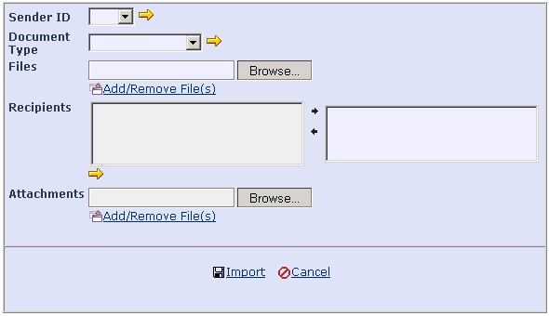
Nike
Prada
- Select the business entity for the Sender ID field. If the business entity you want to select is not found, click on the icon to create a new business entity.

- Select Document Type. If the document type you want to select is not found, click on the icon to create a document type.

- To select the file from your system, click Browse. The Choose File window appears. Once the file is selected and displayed at the Files field, the Add/Remove File(s) will be enabled. Click this hyperlink. You will see the selected file, together with its blank checkbox, appears. You may add more files if you need to import more files. If you tick the checkbox, and click Add/Remove Files, the selected file will be removed.

- Next go to Recipients where you can select which partners are to receive your files. If the partner you want is not listed in the left listbox, click on the icon to create a new partner.

- If you wish to attach files from your system, click Browse. The Choose File window appears. Once the file is selected and displayed at the Attachments field, the Add/Remove File(s) will be enabled. Click this hyperlink. You will see the selected file, together with its blank checkbox, appears. You may add more files if you need to import more files. If you tick the checkbox, and click Add/Remove Files, the selected file will be removed.

- Next click the Import hyperlink to send the files to the selected partner. You will see the files you have selected are imported into GridTalk and displayed in the All Documents and Import Documents list view pages.

- To select and delete the files from the Import folder, go to the left panel of System Folders and click Import. Select the document and tick its checkbox. Then click Delete Documents. You will be prompted to the Microsoft Internet Explorer window asking you, “Are you sure you wish to delete these Documents?” If you want to delete them, click Yes. You will see the deleted file is removed from the table at the Import Documents list view page.

Managing documents in the Outbound Folder

The document Outbound folder is one of the two final destination folders for any document. Once in the Outbound folder, no more changes can be made to the document exception deleting it. A document can only flow to the Outbound folder through the partner function processing. You may only perform view and delete operations on documents in the Outbound folder.

To view the outbound folder

Click “Outbound” in the navigation tree (accessed by clicking the “Documents” tab). This will bring you to Outbound Documents folder where you can delete business documents in the table. The columns in the table represent the following information:

GridDoc ID:
It is the unique ID number in the Outbound Folder used for tracking purposes.

Has Attachments:
Indicates whether the business document has any files attached. If Yes, it means the business document has attached files. If No, the business document has no attached files.

Doc. Type:
Type of the business document. For example, 34A Purchase Order Request, Unclassified, etc.

Doc. No:
Document number (if applicable) of the business document.

Recipient Partner ID:
Recipient’s Partner ID as defined by the sender.

Doc. Filename:
Filename of the business document. For example, PO.xml

Audit File:
Filename of the audit document. For example, 3C3.xml

Transaction Status:
The transaction status of the business document. For example, “processed”

Channel Name:
Name of the channel the document is sent via as defined by the sender.

Route via:
This indicates whether the document is directly sent to partner or routed via some other means to partner.

Date/Time Sent:
Time/date when sending of the document began.

Date/Time Transacted:
Time/date when document is received at the recipient partner and processed at the Inbound Folder. For RosettaNet documents, this means an RosettaNet acknowledgment receipt has been returned from the recipient partner.

User Tracking ID:
User tracking identifier extracted from the business document, if any.

Process Instance UID:
Process Instance ID of the process the business document participates in. This is unique with respect to the initiator of the business process.

To manually send a document

Manual send operation can only be performed on documents in the Import folder, also provided that a manual send partner function processing is already defined by your Administrator for that type of document that you select for manual send. This function may be used to resend your document if it fails to send out to your partner possibly due to configuration errors, or used as part of your business process flow to allow you to make modification to a received document and send it back to the original sender partner.

- In the Import Documents list view page, select the document files to be sent.

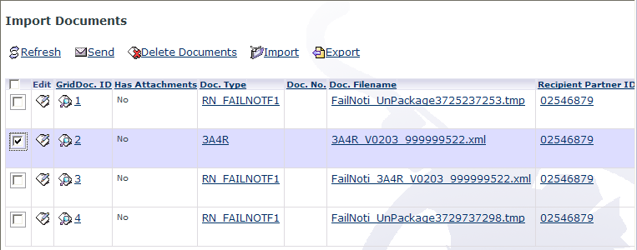

- Click Send. You will be prompt to confirm sending:

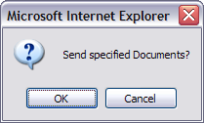

- Click Ok to send the selected documents.

Managing documents in the Inbound Folder

The Inbound folder contains those documents that you received from your partners. Depending from the partner function processing, a received document may then flow to the Export or Import folder. You may perform manual export, view and delete operations on documents in the Inbound folder.

To view the inbound folder

Click “Inbound” in the Document navigation tree. This will bring you to the Inbound Documents folder where you can delete business documents in the table. The columns in the table represent the following information:

GridDoc ID:
It is the unique ID number in the Inbound Folder used for tracking purposes.

Has Attachments:
Indicates whether the business document has any files attached. If Yes, it means the business document has attached files. If No, the business document has no attached files.

Doc. Type:
Document type (as defined by user) of the business document.

Doc. No:
Document number (if any) of the business document.

Sender Partner ID:
Sender’s partner ID, as defined by receiver.

Doc. Filename:
Filename of the business document.

Audit File:
Filename of the audit document.

Transaction Status:
The transaction status of the business document.

Route via:
This indicates whether the document is directly received from partner or routed via GridMaster from partner.

Date/Time Received:
Time/date when document is fully received in the folder.

User Tracking ID:
User tracking identifier extracted from the business document, if any.

Process Instance UID:
Process Instance ID of the process the business document participates in. This is unique with respect to the initiator of the business process.

Managing documents in the Export Folder

The Export folder is one of the 2 final destination folders for a document. It contains documents that you want to export out from GridTalk to your backend systems. Depending on the partner function processing, a document in the Export folder may originate from a document from the Inbound or Import folder. You may only perform view and delete operations on documents in the Export folder.

To view the export folder

Click Export in the Document navigation tree. This will bring you to the Export Documents folder where you can delete business documents in the table. The columns in the table represent the following information:

GridDoc ID:
It is the unique ID number in the Export Folder used for tracking purposes.

Has Attachments:
Indicates whether the business document has any files attached. If Yes, it means the business document has attached files. If No, the business document has no attached files.

Doc. Type:
Document type (as defined by user) of the business document.

Doc. No:
Document number (if any) of the business document.

Sender Partner ID:
Sender’s partner ID, as defined by receiver, if any.

Doc. Filename:
Filename of the business document.

Export via:
This indicates the port via which the document is exported out of GridTalk.

Date/Time Exported:
Time/date when document is exported out of GridTalk

User Tracking ID:
User tracking identifier extracted from the business document, if any.

Process Instance UID:
Process Instance ID of the process the business document participates in. This is unique with respect to the initiator of the business process.

To manually export a document

This manual export may be used if you fail to export the documents into the backend system automatically when the document is received or imported. Using this feature, you can manually export documents from the Import/Inbound folders to the Export folder.

- In the Import Documents or Inbound Documents list view page, select the document files to be exported.

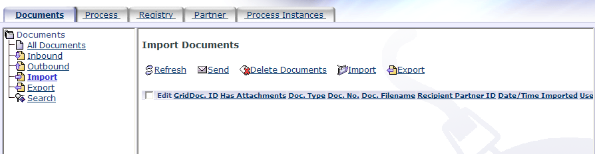

- Click on the Export link on top of the list view. When the message, “Export Specified Documents?” is prompted, click OK.

- The default partner function for Manual Export will be used if you do not define your own Manual Export partner function. See more details in the GridTalk 4.2 Administration Guide for creating a partner function. If the manual export partner function configures Exit to port activity, the selected documents are now exported according to the specified port.

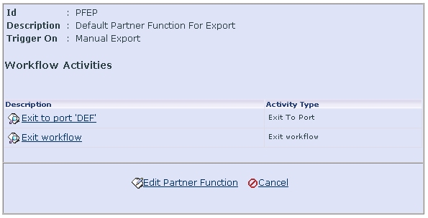

Document Searching

This feature is designed to allow the user to search the documents in the four system folders. You can search for documents either by the fields in the GridDocument or by using XPaths if the user document is in XML format. This is done by setting and saving the criteria in the form of a search query.

You may make as many queries as you require.

The criteria for the queries are specified by means of defining filters based on the contents from GridDocument (required) and User Document (optional).

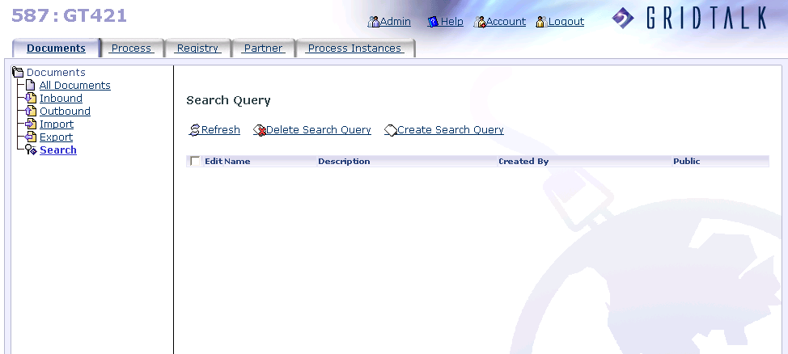

Configuring Search Queries

To create a search query for searching by Grid Document

- Click “Search” in the navigation tree (which is accessed by way of the “Documents” tab). The browser will bring you to the Search Query list view page.

- In the Search Query list view page, click Create Search Query. Then the Create Search Query detail view page will show up for you to create a new search query.

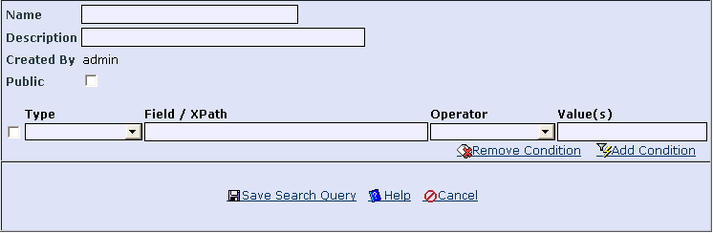

- Enter Name and Description for that search query you are creating.

- Next you will have to set the criteria for the Search Query. There are two types of criteria – Grid Document and User Document.

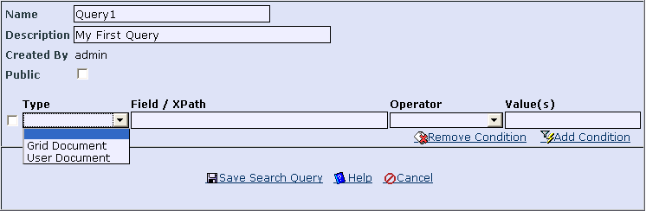

- If you choose Grid Document, the Field / XPath list will be displayed for you to select the GridDocument field.

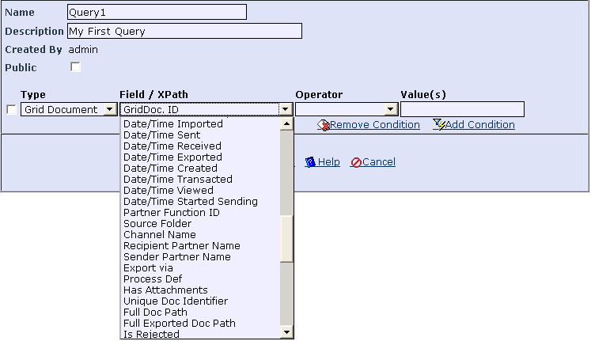

- Next choose the operator you want for this criteria.

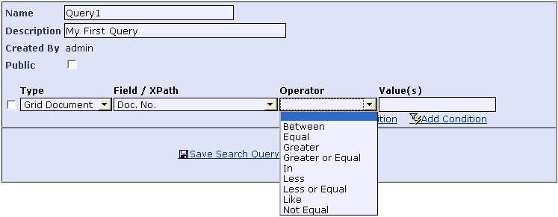

- Next enter the value you want to search for.

- To add another search criterion, click on the Add Condition link. Then you will see the second new row appear below the completed first row. To remove a condition, tick the checkbox next to the selected condition, and then click on the Remove Condition link. The condition(s) checked will be deleted.

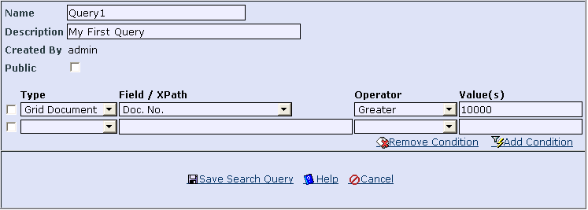

- To share the search query with the other user in the application, check the checkbox Public. By default, the search query will only be viewed by the owner who created this query.

If the search query is set as Public, the other user is allowed to modify the query but only owner or the user with Admin role is allowed to delete such query.

- To save the Search Query, click on the Save Search Query link. The search query’s name will be reflected and shown under Search in the navigation tree. (See Step 7 in Chapter 7.1.2).

- Refer to Chapter 7.2 to run the search query and view the search results.

To create a search query for searching by user document

- Click “Search” in the navigation tree (which is accessed by way of the “Documents” tab). The browser will bring you to the Search Query list view page.

- In the Search Query list view page, click Create Search Query. Then the Create Search Query detail view page will show up for you to create a new search query.

- Enter Name and Description for that search query you are creating.

- Next you will have to set the criteria for the Search Query. There are two types of criteria – Grid Document and User Document. It is required for you to set Grid Document criteria (refer to Step 5 through Step 8 of Chapter 7.1.1 for details).

- If you choose User Document, enter the XPath that points to the value in the user document that you want to search.

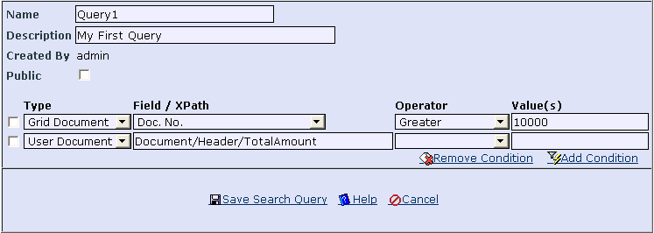

- Next choose the operator. Some operator requires you to enter 2 or more values for the search condition, e.g. Between and In. To enter multiple values, use either a common “,” or a semi-colon “;” to separate the values.

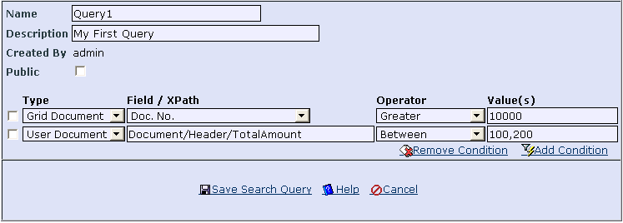

- To share the search query with the other user in the application, check the checkbox Public. By default, the search query will only be viewed by the owner who created this query.

If the search query is set as Public, the other user is allowed to modify the query but only owner or the user with Admin role is allowed to delete such query.

- To save the Search Query, click on the Save Search Query link. Then the search query’s name will be displayed under Search in the navigation tree. For example, Query1. Click on the link of that name, and upon clicking it, the search query will be executed. Later you will see the Search Query you have just created in the Search Query list view page.

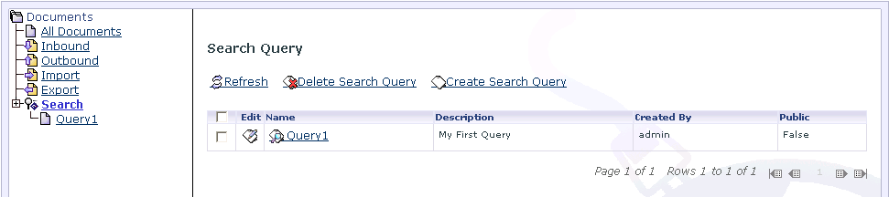

- To remove a condition, tick the checkbox next to the selected condition, and then click on the Remove Condition link. The condition(s) checked will be deleted.

- Refer to Chapter 7.2 to run the Search Query and view the search results.

Running Search Queries

After configuring the search query, you need to run it in order to view the listing of documents that match the search query conditions.

To run a search query and view searched documents

- To start searching, click on the name of the Search Query on the left side of the browser in the navigation tree view. This will bring you to the Searched Documents list view page where you see all documents that have satisfied the criteria you have set and saved earlier.

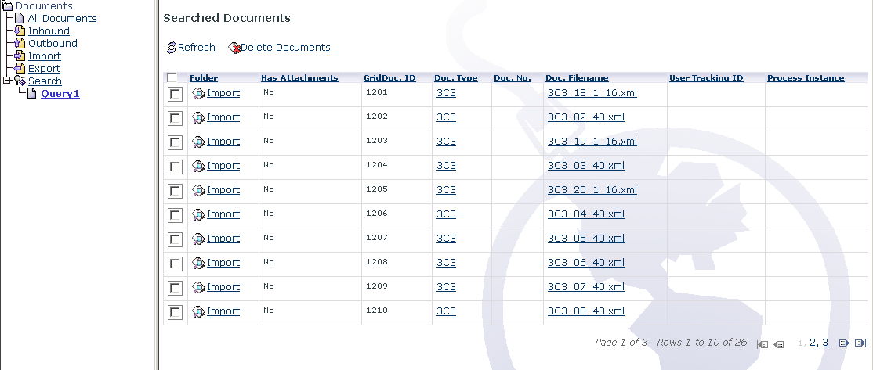

- To view the details of a document from the Searched Documents list view page, click the hyperlink under the Folder column of the document to view. To view the business document, click on the hyperlink under the Doc. Filename column.

- If you want to edit the search query, go to the Search Query list view page and click on the Edit icon next to the selected Search Query under Search Query in the list view.

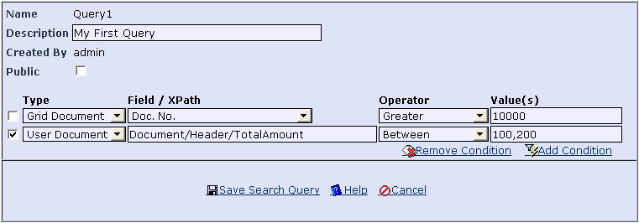

- Make the necessary additions, removals or modifications of conditions and save the search query.

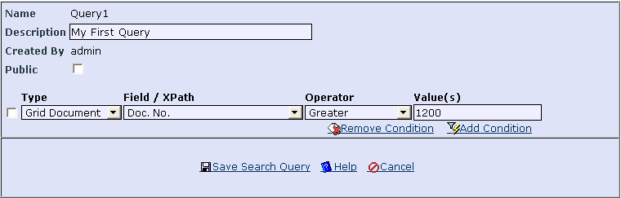

- To view the results of applying the updated Search Query, repeat Step 1.

COPYRIGHT
This User Guide contains information, which is proprietary to CrimsonLogic eTrade Services Pte Ltd. No part of this User Guide may be reproduced in any material form (including photocopying or storing it in any medium by electronic means and whether or not transiently or incidentally to some other use of this publication) without the written permission of CrimsonLogic eTrade Services Pte Ltd except in accordance with the Copyright Act of Singapore (Cap. 63).

